# ASSIGNMENT-3

|  |  |
| --- | --- |
| NAME | R.SIVARAMAN |
| ASSIGNMENT NAME | Build wowki product, use ultrasonic sensor and detect the distance from the object. Whenever distance is less than 100cms |

LINK: <https://wokwi.com/projects/364407615995638785>

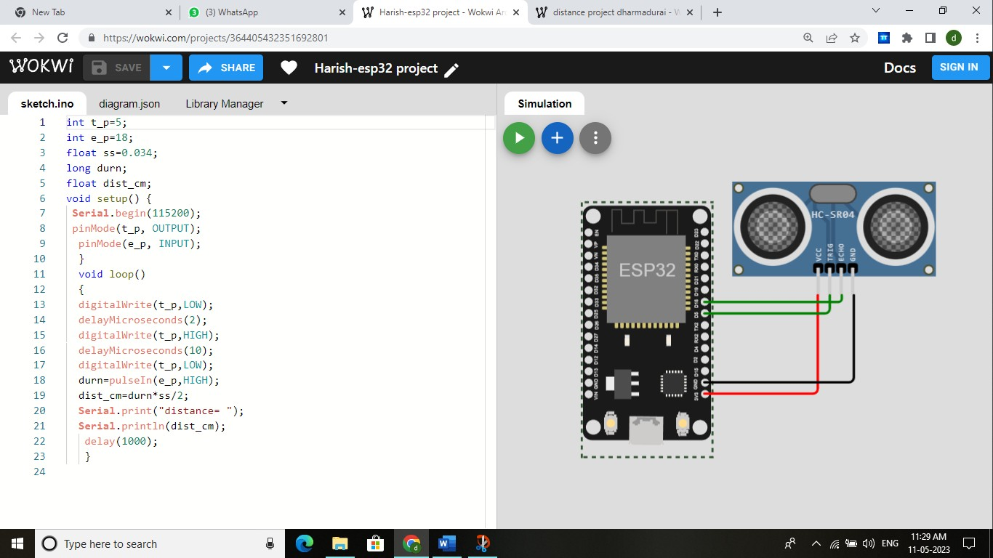

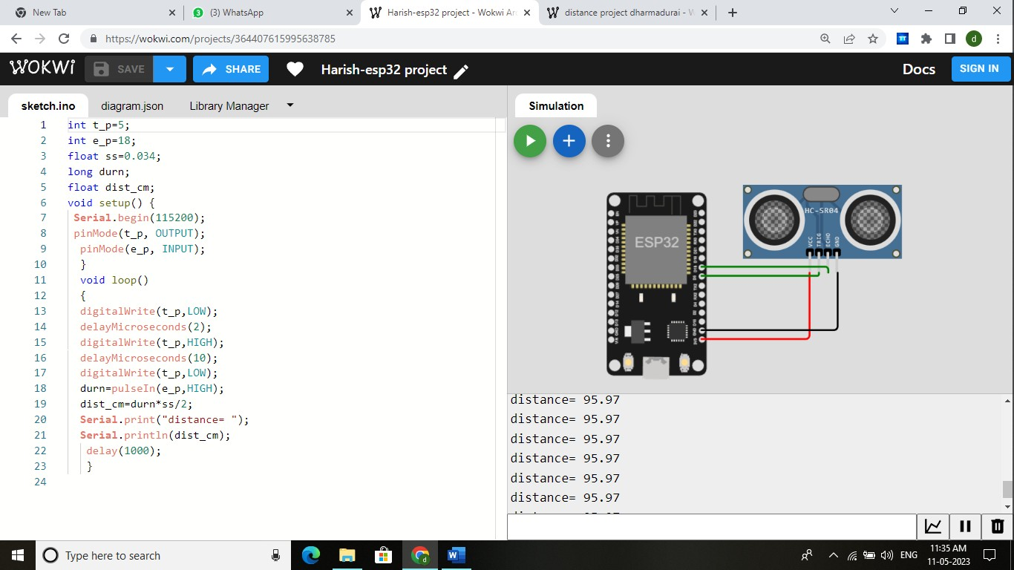

# PROGRAM:

int t_p=5; int e_p=18;

float ss=0.034; long durn; float dist_cm;

void setup() {

**Serial**.begin(115200); pinMode(t_p, OUTPUT); pinMode(e_p, INPUT);

}

void loop()

{

digitalWrite(t_p,LOW); delayMicroseconds(2); digitalWrite(t_p,HIGH); delayMicroseconds(10); digitalWrite(t_p,LOW); durn=pulseIn(e_p,HIGH);

dist_cm=durn*ss/2; **Serial**.print("distance= "); **Serial**.println(dist_cm);

delay(1000);

}